

JAVA PROJECT REPORT ON

SECURE USER LOGIN AND AUTHENTICATION SYSTEM WITH PASSWORD VALIDATION

Submitted by NETHRA.A 25BCS241

Under the Guidance of

DHARANEESH
Technical Trainer
Technical Department, KG College of Arts and Science

Academic Year: 2025 – 2026

APRIL 2026
Semester: I

DECLARATION
I hereby declare that the project entitled “PROJECT TITLE” submitted in partial fulfillment of the requirements for the course [Course Name] is a record of my original work carried out under the guidance of [Trainer Name], Technical Trainer, Technical Department, KG College of Arts and Science.
I further declare that this project has not been submitted previously, either in part or in full, for the award of any degree, diploma, or other similar title, at this or any other institution.
I have acknowledged all sources of information used in this project wherever applicable.

April 2026 Coimbatore

NETHRA.A

(Your Name)

CERTIFICATE
This is to certify that the project entitled “PROJECT TITLE” is a bona fide work carried out by [YOUR NAME] [Class/Batch], [Department Name], KG College of Arts & Science, in partial fulfillment of the requirements for the course [Course Name].
This project has been completed under my supervision and guidance during the academic period April 2026.

Place: COIMBATORE
Date:10.04.2026

Submitted for the Viva-Voce Examination held on

10.04.2026

DHARANEESH BOOPALAN
Guide: Head of the Department
(Technical Trainer) (TechnicaHead,KGCAS)

TABLE OF CONTENTS

S. No. | Topics | Page. No.
1 | Introduction
1.1 | Objective
1.2 | Overview
1.3 | Features
2 | Program Analysis
2.1 | Problem Definition
2.2 | Project Overview
2.3 | Scopes and Limitations
3 | System Design
3.1 | Modules
4 | Methodology
4.1 | Problem Analysis
4.2 | System Design
4.3 | Program Development
4.4 | Testing and Validation
4.5 | Result and Documentation
4.6 | Algorithm
4.7 | Flowchart
5 | Source Code
6 | Input and Output Screens
7 | Discussion and Conclusion
7.1 | Discussion
7.2 | Conclusion
8 | References

ABSTRACT
The Secure User Login and Authentication System with Password Validation is a Java-based application designed to ensure safe and reliable user access to a system. In many applications, weak authentication methods can lead to unauthorized access, data breaches, and security risks. This project aims to enhance system security by implementing a strong login mechanism with proper password validation.
The system allows users to register and log in using a username and password. During registration, the password is validated based on specific rules such as minimum length, use of uppercase and lowercase letters, numbers, and special characters. During login, the system verifies the entered credentials with stored data to grant or deny access.
The application is developed using Core Java concepts, including classes, objects, methods, conditional statements, loops, and exception handling. It can be implemented as a console- based program or extended using Java Swing for a graphical user interface.
The main objective of the system is to improve security, prevent unauthorized access, and protect user data. The system ensures that only valid users can access the application and provides feedback for incorrect login attempts or invalid password formats.
This project demonstrates the practical implementation of authentication techniques and password validation rules using Java and serves as a foundation for developing secure software systems in real-world applications.

INTRODUCTION
In today’s digital world, secure user authentication plays a vital role in protecting systems and sensitive information from unauthorized access. Many applications still use weak login mechanisms, where passwords are not properly validated, leading to security vulnerabilities such as data breaches and unauthorized system usage. Manual or poorly designed authentication systems can result in compromised user accounts and loss of important data.
With the advancement of technology, secure login and authentication systems have become essential for ensuring data protection and user privacy. A well-designed authentication system helps verify user identity, enforce strong password rules, and prevent unauthorized access to applications. It also improves system reliability and builds user trust.
The Secure User Login and Authentication System with Password Validation is a Java-based application developed to provide a safe and efficient login process. The system allows users to register with a username and password, where the password must meet specific validation criteria such as minimum length, inclusion of uppercase and lowercase letters, numbers, and special characters. During login, the system verifies the entered credentials with stored user data and grants access only if the information is correct.
This project is developed using Core Java programming concepts such as classes, objects, methods, conditional statements, loops, and exception handling. The application can be implemented as a console-based program or enhanced using Java Swing to provide a graphical user interface (GUI).
The main objective of this system is to enhance security, reduce the risk of unauthorized access, and ensure proper user authentication. This project also demonstrates how Java can be effectively used to build secure and reliable real-world applications.

  - Objective
The main objective of the Secure User Login and Authentication System with Password Validation is to develop a simple and secure application using Core Java that ensures safe user authentication and protects systems from unauthorized access.
The specific objectives of this project are:
    - To design and develop a Java-based secure login and authentication system.
    - To implement password validation rules such as minimum length, uppercase and lowercase letters, numbers, and special characters.
    - To verify user credentials during login and allow access only to authorized users.
    - To prevent unauthorized access and improve overall system security.
    - To provide a user-friendly interface for registration and login processes.
    - To demonstrate the implementation of Core Java programming concepts such as classes, objects, methods, loops, and conditional statements.

    - To display appropriate messages for successful login, failed attempts, and invalid password formats.

  - Overview
The Secure User Login and Authentication System with Password Validation is a menu- driven application developed using the Java programming language. The system provides a secure platform where users can register and log in by entering valid credentials.
The system allows new users to create an account by providing a username and password. During registration, the password is validated based on predefined rules such as minimum length, inclusion of uppercase and lowercase letters, numbers, and special characters. For existing users, the system verifies the entered login credentials with the stored data to grant or deny access.
The application ensures that only authorized users can access the system, thereby improving security and protecting sensitive information. It also provides appropriate messages for successful login, incorrect credentials, and invalid password formats.
The system helps simplify the authentication process by automating user verification and reducing the risk of unauthorized access. The application can be developed as a console- based program or enhanced with a graphical user interface using Java Swing.
This project demonstrates the practical use of Java programming in developing secure and reliable real-world applications, especially in systems where user authentication and data protection are essential.

  - Features
The Secure User Login and Authentication System with Password Validation includes the following main features:
    - User Registration – Allows new users to create an account by entering a username and password.
    - Password Validation – Ensures that the password meets security requirements such as minimum length, use of uppercase and lowercase letters, numbers, and special characters.
    - User Login – Enables registered users to log in by entering valid credentials (username and password).
    - Authentication Process – Verifies user credentials with stored data and grants access only to authorized users.

    - Error Handling – Displays appropriate messages for incorrect login attempts or invalid password formats.
    - Security Enhancement – Prevents unauthorized access and improves data protection through proper validation techniques.
    - User-Friendly Interface – Provides a simple and easy-to-use menu-driven interface for registration and login.
    - Fast and Efficient Process – Reduces the time required for user verification and ensures quick access to the system.

PROGRAM ANALYSIS
Program analysis is an important phase in software development where the problem is studied in detail and the requirements of the system are clearly identified. This stage helps in understanding how the authentication system should function and what security features are necessary to protect user data effectively.
The analysis phase focuses on identifying the issues in existing authentication systems, such as weak passwords, lack of proper validation, and unauthorized access. These problems can lead to security risks and data breaches. To overcome these issues, a secure and reliable login system is required.
The proposed system introduces a computerized solution that validates user passwords based on predefined rules and verifies login credentials before granting access. This improves system security, ensures data protection, and provides a reliable authentication process. The analysis also helps in defining system requirements such as user registration, password validation, login verification, and error handling.
This phase ensures that the system is designed to meet security standards while maintaining simplicity and efficiency in operation.

  - Problem Definition

In many applications, user authentication is often implemented with weak security measures or without proper password validation. This traditional or poorly designed approach creates several challenges and security risks.
Some common problems include:
    - Use of weak passwords that are easy to guess
    - Lack of proper password validation rules
    - Unauthorized access to the system
    - Difficulty in managing user credentials securely
    - Increased risk of data breaches and misuse
Weak authentication systems increase the chances of security threats and can compromise sensitive user information. It may also reduce user trust in the system due to poor data protection.
Therefore, there is a need for a secure login and authentication system that validates passwords effectively and ensures that only authorized users can access the application.
The Secure User Login and Authentication System with Password Validation is designed to solve these problems by providing a computerized solution that enforces strong password rules and verifies user credentials securely.

  - Project Overview
The Secure User Login and Authentication System with Password Validation is a Java-based application developed to ensure secure access to systems by verifying user credentials effectively.
The system provides a menu-driven interface where users can register and log in using a username and password. During registration, the system validates the password based on predefined security rules. During login, the system checks the entered credentials against stored data and allows access only if the details are correct.
The system includes the following functionalities:
    - Registering new users with username and password
    - Validating password strength based on security rules
    - Allowing users to log in using valid credentials
    - Verifying user authentication before granting access
    - Displaying appropriate messages for successful or failed login attempts
This project is implemented using Core Java programming concepts and can be developed as either a console-based program or a Java Swing GUI application.
.
  - Scopes and Limitations

Scope
The scope of the Secure User Login and Authentication System with Password Validation includes the following:
    - Managing user registration and login processes
    - Validating passwords based on predefined security rules
    - Verifying user credentials to allow secure access
    - Providing protection against unauthorized system access
    - Demonstrating the practical use of Java programming concepts in security applications
The system can be used in:
    - Educational applications
    - Banking systems (basic level)
    - Online portals and websites
    - Office management systems
    - Any application requiring secure user authentication
Limitations
The system has some limitations, such as:
    - Stores user data locally without advanced encryption techniques
    - Limited to basic password validation rules
    - Does not include advanced security features like OTP or biometric authentication
    - Not suitable for large-scale applications without further enhancements
    - Requires additional security measures for real-time and high-security environments

SYSTEM DESIGN
System design is the stage where the structure and components of the system are planned before the actual implementation. In this phase, the system is divided into different modules, and the workflow of the application is clearly defined. Proper system design helps in organizing the program efficiently and makes development easier and more secure.
The Secure User Login and Authentication System with Password Validation is designed as a menu-driven application where users can register and log in using valid credentials. The system ensures that passwords follow specific validation rules and only authorized users are allowed to access the system.
The system is divided into several modules to perform specific tasks. Each module is responsible for handling a particular function of the system, such as user registration, password validation, login authentication, and error handling. This modular design improves the maintainability, security, and efficiency of the application.

Modules
The main modules of the Secure User Login and Authentication System with Password Validation are explained below:
- User Registration Module
This module is responsible for allowing new users to create an account by entering a username and password. The system ensures that user details are stored for future login.
Functions of this module include:
  - Accepting username and password input
  - Storing user credentials securely
  - Preparing data for authentication
The registration process is the first step for accessing the system.

- Password Validation Module
This module ensures that the password entered by the user meets the required security criteria.
Functions of this module include:
  - Checking minimum password length
  - Verifying the presence of uppercase and lowercase letters
  - Ensuring inclusion of numbers and special characters
  - Rejecting weak or invalid passwords

This module helps in strengthening system security by enforcing strong password rules.

- User Login Module
This module allows registered users to log in by entering their username and password.
Functions of this module include:
  - Accepting login credentials
  - Verifying entered data with stored user information
  - Allowing or denying access based on validation
The login process ensures that only authorized users can access the system.

- Authentication Module
This module handles the verification process and controls user access.
Functions of this module include:
  - Matching username and password
  - Granting access for valid users
  - Displaying error messages for invalid attempts
This module acts as the core security component of the system.

- Exit Module
This module allows the user to safely exit the application after completing the login or registration process.
When the user selects the exit option, the system terminates the program securely. It ensures that all processes are properly closed and prevents unauthorized access after the session ends.

METHODOLOGY
Methodology describes the process followed to develop the project. It explains the steps taken from understanding the problem to designing, implementing, testing, and documenting the system.

For the Secure User Login and Authentication System with Password Validation, a structured development approach was followed to ensure that the system provides secure and reliable user authentication.

The development process includes the following stages:
- Problem Analysis
- System Design
- Program Development
- Testing and Validation
- Result and Documentation

  - Problem Analysis

.In this phase, the problem is studied and analyzed in detail. The requirements of the system are identified based on the need for secure user authentication and data protection.
The main problems identified in existing authentication systems are:
    - Weak passwords that are easy to guess
    - Lack of proper password validation mechanisms
    - Unauthorized access to the system
    - Poor management of user credentials

These issues can lead to security risks, data breaches, and misuse of sensitive information.

Based on these problems, the system requirements were defined to develop a secure login and authentication application that validates passwords effectively and ensures that only authorized users can access the system.

  - System Design
In this stage, the overall structure of the system is designed before coding begins. The system is divided into modules such as:
    - User Registration Module

    - Password Validation Module
    - User Login Module
    - Authentication Module
    - Exit Module

The program flow and structure are designed so that users can easily interact with the system. Each module performs a specific function, ensuring that the authentication process is secure, efficient, and easy to use.

  - Program Development

After designing the system, the program is implemented using the Java programming language.
The following steps were followed during development:
    - Creation of classes and methods
    - Implementation of menu-driven logic for registration and login
    - Writing code for password validation
    - Handling user input for username and password
    - Verifying login credentials and displaying appropriate messages

Core Java concepts such as classes, objects, loops, conditional statements, and methods were used during development to build a secure and efficient authentication system.

4.4 Testing and Validation

Testing ensures that the program works correctly and produces the expected results. Different test cases were used to check the functionality and security of the system. Example Test Cases:
Test Case Expected Result User registration User details stored successfully Valid password Password accepted

Test Case Expected Result

Invalid password | Error message displayed
Correct login credentials | Access granted
Incorrect login credentials | Access denied

This phase ensures that the program runs without errors, validates passwords correctly, and provides secure authentication with accurate results.

  - Result and Documentation

After successful testing, the results of the system are documented. The system verifies user credentials and provides access only to authorized users based on valid username and password input.
The results are demonstrated through program execution and screenshots showing the registration process, password validation, and login authentication outcomes.

Proper documentation is prepared to explain the design, implementation, and working of the system. This includes details about password validation rules, authentication process, and handling of successful and failed login attempts.

  - Algorithm

Algorithm for the Secure User Login and Authentication System with Password Validation:
    - Start the program.

    - Display menu options: Register / Login / Exit.

    - If the user selects Register:

    - Enter username and password.

    - Validate the password based on rules (length, uppercase, lowercase, number, special character).
    - If the password is valid, store the user details.

    - Else, display an error message and ask to re-enter the password.

    - If the user selects Login:

    - Enter username and password.

    - Check the entered credentials with stored data.

    - If credentials match, display "Login Successful".

    - Else, display "Invalid Username or Password".

    - Repeat steps until the user selects Exit.

    - End the program.

  - Flowchart

Students should draw a flowchart showing the program flow of the secure login and authentication system.

Example flow:
Start
↓
Display Menu (Register / Login / Exit)
↓
User Selection
↓
If Register → Enter Username & Password
↓
Validate Password
↓
If Valid → Store Details

Else → Show Error
↓
If Login → Enter Username & Password
↓
Verify Credentials
↓
If Correct → Login Successful Else → Access Denied
↓
Exit Option
↓ End
Students can draw using:
- draw.io
- Lucidchart
- MS Visio

SOURCE CODE

Include important parts of the Java code such as:
- Main class
- Menu logic (Register / Login / Exit)
- Password validation
- User authentication EXAMPLE:
import java.util.Scanner;

class LoginSystem {

static String storedUsername = "admin";
static String storedPassword = "Admin@123";

public static void main(String[] args)
{ Scanner sc = new Scanner(System.in); int choice;

do {
System.out.println("\n1. Register\n2. Login\n3. Exit"); System.out.print("Enter choice: ");
choice = sc.nextInt(); sc.nextLine();

switch (choice)
{ case 1:
System.out.print("Enter username: "); storedUsername = sc.nextLine();

System.out.print("Enter password: "); String password = sc.nextLine();

if (validatePassword(password))
{ storedPassword = password; System.out.println("Registration Successful");
} else {
System.out.println("Invalid Password Format");
}
break;

case 2:
System.out.print("Enter username: "); String user = sc.nextLine();

System.out.print("Enter password: "); String pass = sc.nextLine();

if (user.equals(storedUsername) && pass.equals(storedPassword))
{ System.out.println("Login Successful");
} else {
System.out.println("Invalid Username or Password");
}
break;

case 3:
System.out.println("Exiting..."); break;

default:
System.out.println("Invalid Choice");
}
} while (choice != 3);

sc.close();
}

static boolean validatePassword(String password)
{ return password.length() >= 8 && password.matches(".*[A-Z].*") &&

password.matches(".*[a-z].*") &&
password.matches(".*[0-9].*") && password.matches(".*[@#$
%^&+=].*");
}
}

INPUT AND OUTPUT SCREENS

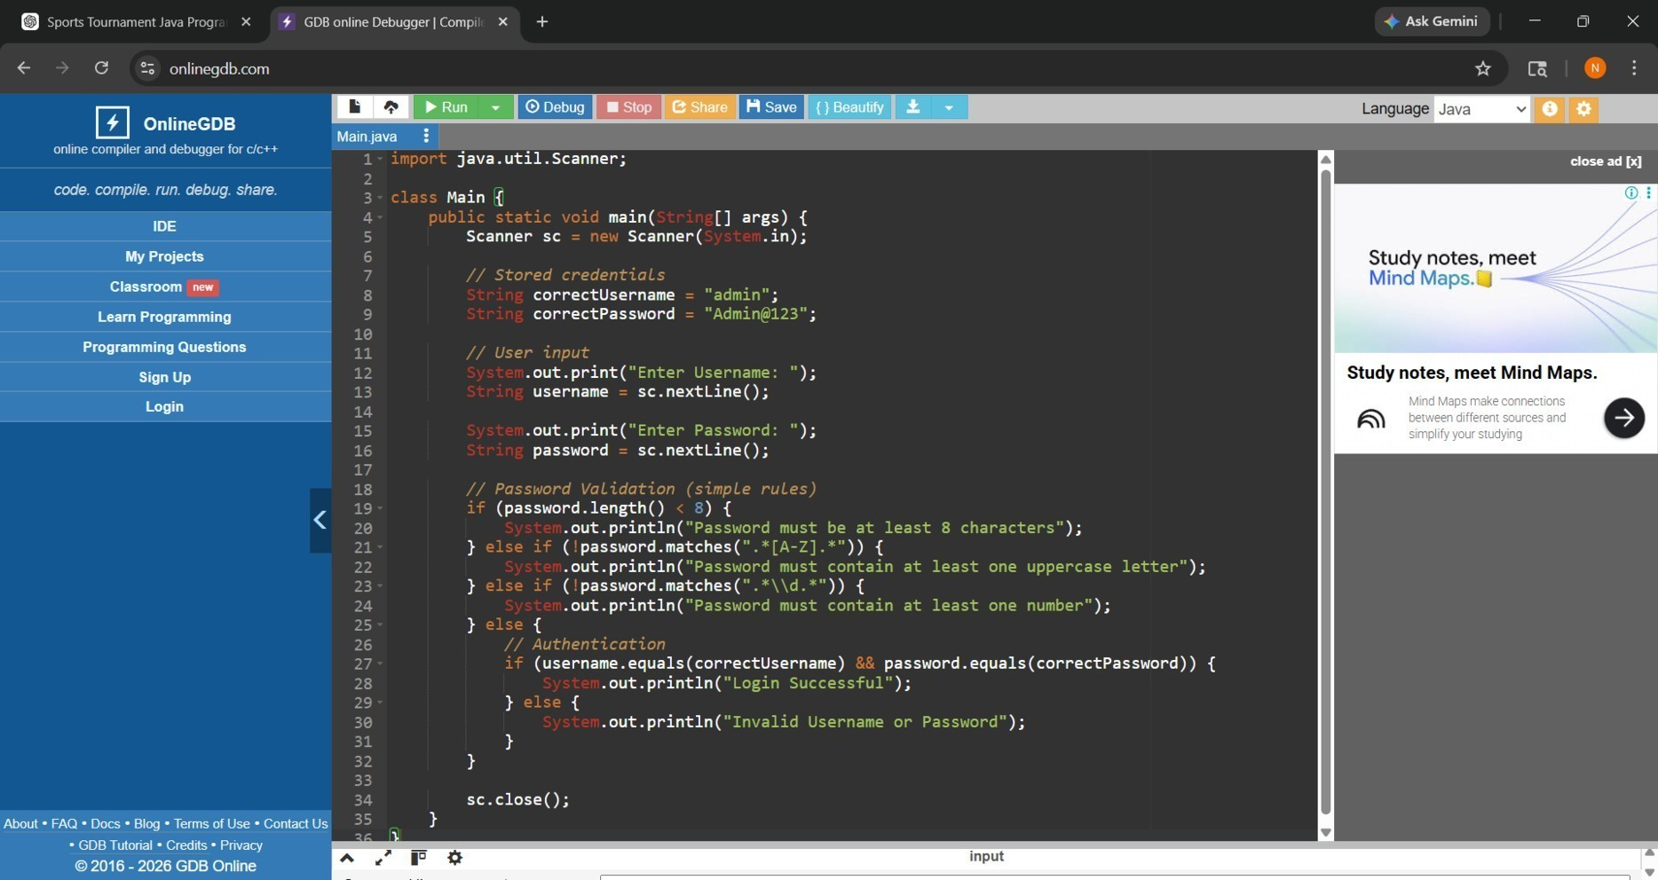

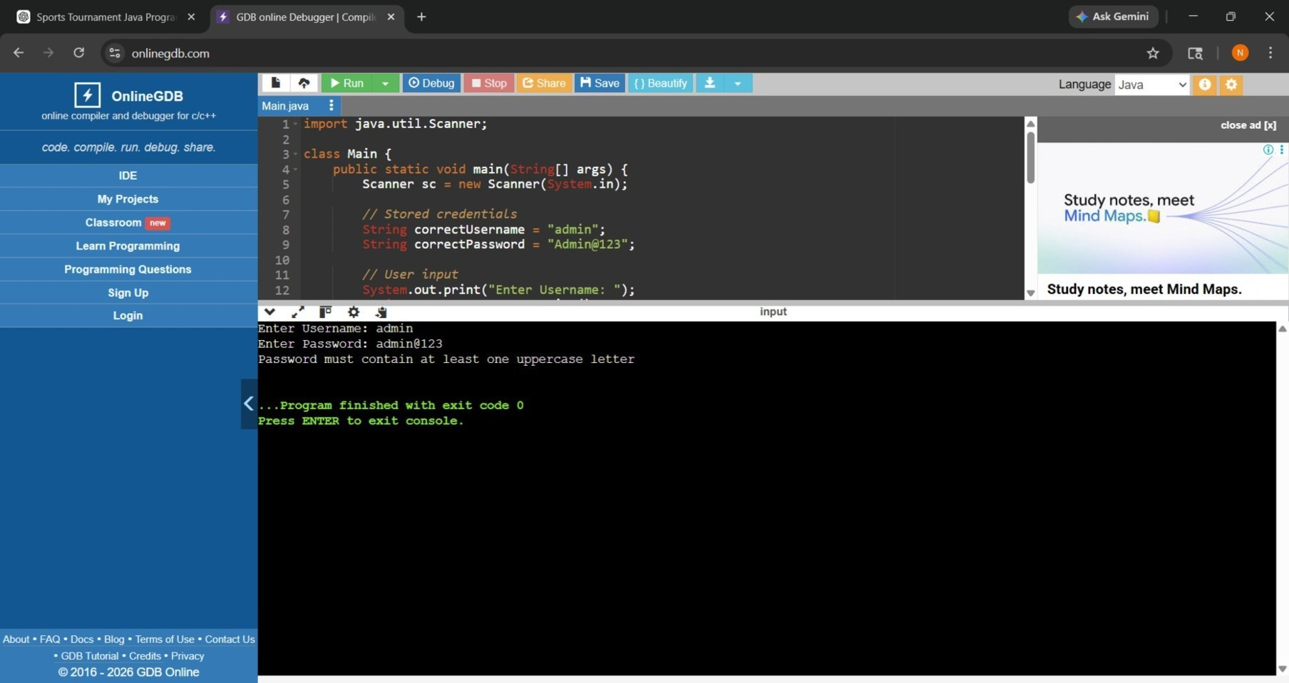

- DISCUSSION & CONCLUSION
  - Discussion
The Secure User Login and Authentication System with Password Validation was developed to provide a secure method for user authentication in applications. The system allows users to register with a username and password, validates the password based on security rules, and enables login only for authorized users.
During the development process, Core Java programming concepts such as loops, conditional statements, methods, and object-oriented principles were applied. The system successfully performs password validation and user authentication efficiently.
The system was tested with different inputs to ensure proper validation of passwords and accurate verification of login credentials. The results show that the system prevents unauthorized access and improves overall security.

  - Conclusion
The Secure User Login and Authentication System with Password Validation successfully demonstrates the practical application of Core Java programming concepts in developing a secure software application.
The system enhances security by enforcing strong password rules and restricting access to authorized users only. It simplifies the authentication process while ensuring data protection and reliability.
This project helps students understand how Java programming can be used to develop secure and real-world applications. The system can be further enhanced by adding features such as database connectivity, encryption techniques, multi-factor authentication (OTP), and graphical user interfaces.

REFERENCES

The following resources were used during the development of this project:
Books
- Java: The Complete Reference
Websites
- Oracle – https://www.oracle.com/java
- GeeksforGeeks – https://www.geeksforgeeks.org
- W3Schools – https://www.w3schools.com
- Javatpoint – https://www.javatpoint.com

